AGEING BOT

## Instructions

App version 1.2

Instructions for “AGEING BOT”

**Please read and follow all the instructions for a proper use of application!**

## Pre-requisites:

1. Details template – should be made on the template presented down below:

In the Details template, provide the header in the exact form as written below:

|  |  |  |  |  |  |  |
| --- | --- | --- | --- | --- | --- | --- |
| Client | Client code | Account | Due date | Invoice no | Amount in LC | Invoice value |
| Name 1 | 00011 | 411 | mm/dd/yyyy | 12345 | 80 | 100 |

***If we have fields that do not exist in PBC, the column names must be added anyway, next to the headers that contain information

1. TB template – should be made on the template presented down below:

In the TB Template, map the information from the Trial Balance provided by the client, onto the Template shown here accordingly. (Account, Description, Opening Balance, Movement Debit & Credit and Closing Balance)

|  |  |  |  |  |  |
| --- | --- | --- | --- | --- | --- |
| Account | Description | OB | DM | CM | CB |
| 411 | Clients | 2.341 | 34.325 | 5.353 | 31.313 |

## Instructions:

1. Open the app:

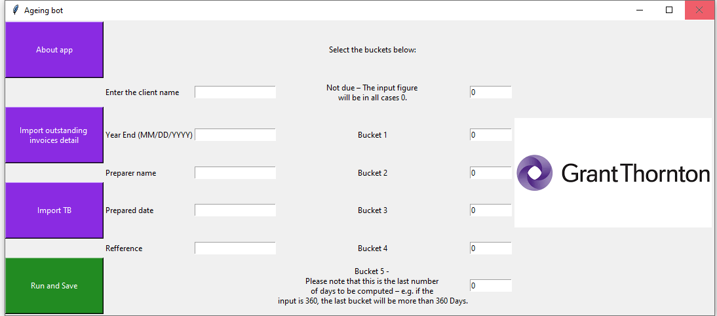

1. Enter the client’s name and the period end (MM/DD/YYYY) of the audit.
2. Click “Import Details” button and select the Details document.
3. Click “Import TB” and import the Trial Balance template.
4. In the following areas, insert your name, date of preparation of the test and desired reference number.
5. Insert the desired days for the buckets to be computed in the right place.

The ageing buckets are:

* Bucket 1: 0 – 30 days
* Bucket 2: 31 – 60 days
* Bucket 3: 61 – 90 days
* Bucket 4: 91 – 180 days
* Bucket 5: 181 – 360 days and over.

1. Click “Run and save”. Once clicking that, the robot will ask the desired saving location, will process your request and exit the application, then announce you if the process succeeded.
2. Finally, you should obtain an Excel document named “Ageing test”, with the client name.

For any issues, questions and/or suggestions, please contact:

Cristian Iordache, [cristian.iordache@ro.gt.com](mailto:cristian.iordache@ro.gt.com)

Bogdan Constantinescu, [bogdan.constantinescu@ro.gt.com](mailto:bogdan.constantinescu@ro.gt.com)